ARYAMAN MISHRA 19BCE1027

LAB1 10-2-21

1. Write a JAVA Program to calculate simple interest and compound interest.

import java.util.Scanner;

class sci {

public static void main(String[] args) {

Scanner sc = new Scanner(System.in);

System.out.print("Enter the principal: ");

double principal = sc.nextDouble();

System.out.print("Enter the rate: ");

double rate = sc.nextDouble();

System.out.print("Enter the time: ");

double time = sc.nextDouble();

System.out.print("Enter number of times interest is compounded: ");

int number = sc.nextInt();

double si=principal\*rate\*time/100;

double ci = principal \* (Math.pow((1 + rate/100), (time \* number))) - principal;

System.out.println("Principal: " + principal);

System.out.println("Interest Rate= " + rate);

System.out.println("Time Duration= " + time);

System.out.println("Number of Time interest Compounded= " + number);

System.out.println("Simple Interest="+si);

System.out.println("Compound Interest= " + ci);

}

}

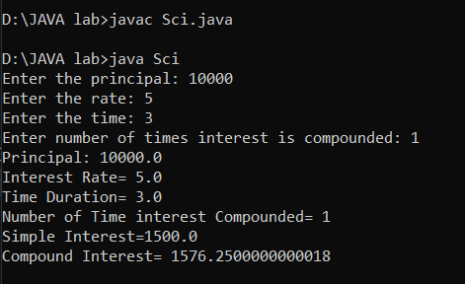

1. Write a JAVA Program to convert celsius temparature to fahrenheit temparature.

import java.util.\*;

class Temperature

{

public static void main (String args[])

{

Scanner sc=new Scanner(System.in);

double Fahrenheit, Celsius;

Celsius=sc.nextInt();

Fahrenheit =((Celsius\*9)/5)+32;

System.out.println("Temperature in Fahrenheit is: "+Fahrenheit);

}}

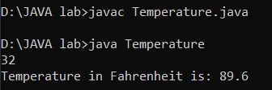

1. Write a JAVA Program to calculate discriminant of a quadratic equation.

import java.util.\*;

class Discriminant

{

public static void main(String args[])

{

Scanner sc=new Scanner(System.in);

int a,b,c;

a=sc.nextInt();

b=sc.nextInt();

c=sc.nextInt();

double d=(b\*b)-(4\*a\*c);

System.out.println(d);

}

}

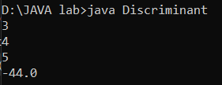

4) Write a JAVA program to display Quotient and Remainder.

import java.util.\*;

class Div {

public static void main(String[] args) {

Scanner sc=new Scanner(System.in);

int num1 = sc.nextInt();

int num2 = sc.nextInt();

int quotient = num1 / num2;

int remainder = num1 % num2;

System.out.println("Quotient is: " + quotient);

System.out.println("Remainder is: " + remainder);

}

}

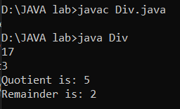

Lab 2 (17-2-1)

1. import java.util.\*;

class JanTemp

{

public static void main(String args[])

{

Scanner sc=new Scanner(System.in);

int a[][]=new int[10][2],i,j,min=100,max=0,maxc=0,minc=0;

System.out.println("Enter 10 city numbers then temperatures in January.");

for(i=0;i<10;i++)

{

for(j=0;j<2;j++)

{

if(j==0)

a[i][j]=sc.nextInt();

else

a[i][j]=sc.nextInt();

}

}

for(i=0;i<10;i++)

{

if(a[i][1]>max)

{

max=a[i][1];

maxc=i;

}

if(a[i][1]<min)

{

min=a[i][1];

minc=i;

}

}

System.out.println("Highest Temperature="+max);

System.out.println("City="+a[maxc][0]);

System.out.println("Lowest Temperature="+min);

System.out.println("City="+a[minc][0]);

}

}

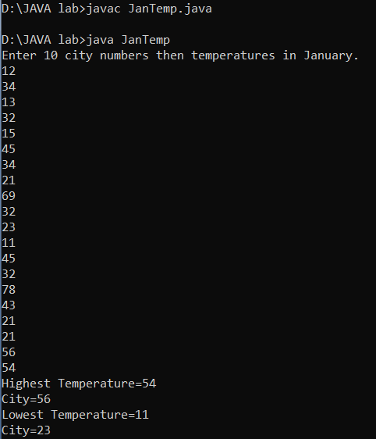

2. import java.util.\*;

class Examcbc

{

public static void main(String[] args)

{

Scanner sc=new Scanner(System.in);

int n,i,j,sum=0,tsum=0,troll=0,stud1=0,stud2=0,stud3=0,max1=0,max2=0,max3=0;

System.out.println("Enter number of students.Take 3 for now.");

n=sc.nextInt();

int a[][]=new int[n][4];

System.out.println("Enter roll no then marks of students in 3 subjects.");

for(i=0;i<n;i++)

{

for(j=0;j<4;j++)

{

a[i][j]=sc.nextInt();

}

}

for(i=0;i<n;i++)

{

for(j=1;j<4;j++)

{

sum+=a[i][j];

}

System.out.println("Sum of roll:"+a[i][0]+" Sum:"+sum);

if(sum>tsum)

{

tsum=sum;

troll=a[i][0];

}

sum=0;

}

for(i=0;i<n;i++)

{

if(a[i][1]>max1)

{

max1=a[i][1];

stud1=a[i][0];

}

if(a[i][2]>max2)

{

max2=a[i][2];

stud2=a[i][0];

}

if(a[i][3]>max3)

{

max3=a[i][3];

stud3=a[i][0];

}

}

System.out.println("In Subject 1 Max Marks:"+max1+" Roll="+stud1);

System.out.println("In Subject 2 Max Marks:"+max2+" Roll="+stud2);

System.out.println("In Subject 3 Max Marks:"+max3+" Roll="+stud3);

System.out.println("In Overall Max Marks:"+tsum+" Roll="+troll);

}

}

